
NOTICE OF ADOPTION
PLEASE NOTE that on Thursday, December 11th the Council of the Municipality of the County of Inverness approved the development agreement and adopted the following amendments:
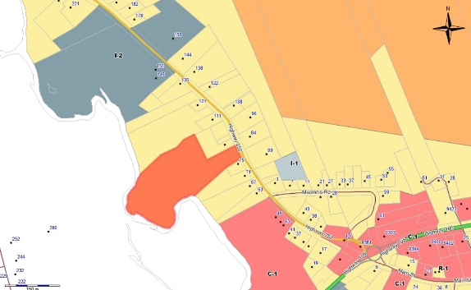

- Development Agreement application by Ms. Adrienne Dermody for a consignment store in a Residential Centre zoned Lot 05-5, 252 Highway, Whycocomagh, Inverness County, NS (PID 50292820).

- Rezoning Request from Residential Rural to Rural Commercial General by Yoshi Holdings Inc. (Last Chance Sandwich) for lands identified by PID# 50102276 (10 La Prairie Road), La Prairie, Inverness County, to expand the current Retail Use to include a Restaurant/Café Use.

PLEASE NOTE that an aggrieved person, an adjacent Municipality, or the Provincial Director of Planning may appeal this decision to the Nova Scotia Utility and Review Board within 14 days of the date of this notice. For more information visit the Eastern District Planning Commission website at www.edpc.ca or phone Toll Free 1- 888-625-5361.

Posted December 12, 2025 on the Municipal Website and in The Oran on December 17, 2025 in accordance with the requirements of the Municipal Government Act.

